**Workshop – Black Box Testing**

**Question1: Boundary Value Analysis**

Assume, we have to test a field which accepts Age 18 – 56



**How many test cases should be checked here?**

**Your answer:**

**Six test cases should be checked: just below minimum, minimum, just above minimum, just below maximum, maximum, and just above maximum.**

**18 56**

**17 19 55. 57**

**Question 2: Equivalence partitioning**

In an Examination, a candidate has to score a minimum of 24 marks in order to clear the exam. The maximum that he can score is 40 marks.  Identify the Valid Equivalence values if the student clears the exam. Please draw also valid and invalid partitions.

a)    22,23,26  
b) 21,39,40  
c)    29,30,31  
d)    0,15,22

**Your answer:**

The Valid Equivalence values are found in answer “c”.

Invalid Valid Invalid

0-23 24-40 41-and more

Partition 3

Partition 2

Partition 1

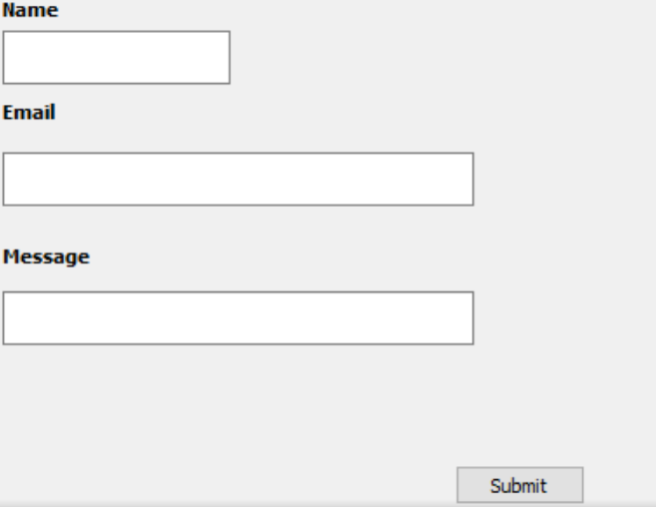**Question 3: Decision table**

**Submit button in Contact Form is**

**enabled when all the inputs are entered by the end user.**

**Your answer: Make decision table with T/F**

|  |  |  |  |  |  |  |  |  |
| --- | --- | --- | --- | --- | --- | --- | --- | --- |
|  | **Test Case1** | **Test Case2** | **Test Case3** | **Test Case4** | **Test Case5** | **Test Case6** | **Test Case7** | **Test Case8** |
| **Name** | **T** | **F** | **T** | **T** | **T** | **F** | **F** | **F** |
| **Email** | **T** | **F** | **F** | **T** | **F** | **T** | **F** | **T** |
| **Message** | **T** | **F** | **F** | **F** | **T** | **T** | **T** | **F** |
| **Submit** | **T** | **F** | **F** | **F** | **F** | **F** | **F** | **F** |

**Question 4: State Transition table**

Login page of an application which locks the user name after three wrong attempts of password.

**Your answers**

1. **Draw State Transition Diagram**

Wrong pin

Wrong pin

3RD ATTEMPT

1ST ATTEPMT

2ND ATTEPMT

START

Right pin

Right pin

Wrong pin

Access Granted

Username locked

1. **Make State Transition table**

|  |  |  |  |
| --- | --- | --- | --- |
| **State** | **Login** | **Correct Password** | **Incorrect Password** |
| S1(1st Attempt) | If S1 is with valid credentials, then – S4.  If S1 is with invalid credentials, then – S2. | S4 | S2 |
| S2(2nd Attempt) | If S2 is with valid credentials, then – S4.  If S2 is with invalid credentials, then – S3. | S4 | S3 |
| S3(3rd Attempt) | If S3 is with valid credentials, then – S4.  If S23 is with invalid credentials, then – S5. | S4 | S5 |
| S4(Access Granted) |  |  |  |
| S5(Username locked) |  |  |  |